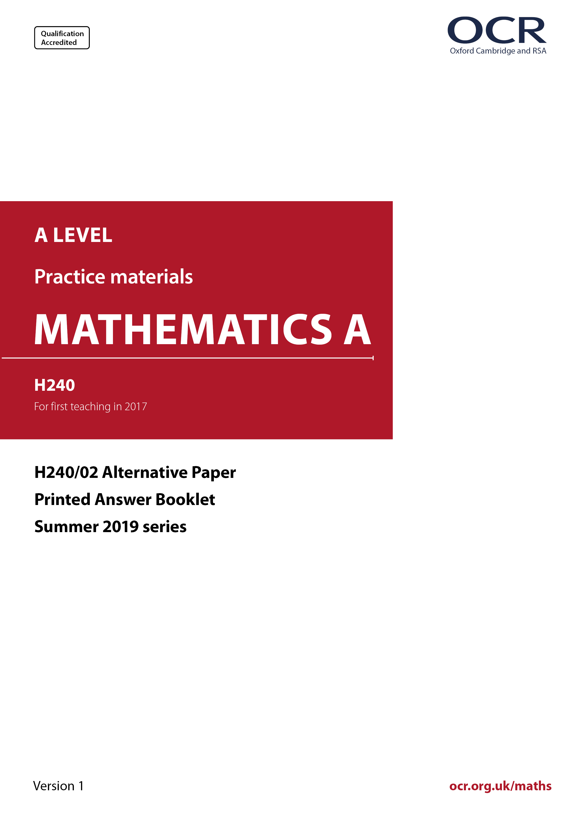

ocr.org.uk/maths

Introduction
OCR’s Alternative Papers for A Level Mathematics A are each created by taking one of our past papers and amending the numbers/graphs/diagrams/tables/etc. in its questions.
This Alternative Paper is an amended version of one of the June 2019 series papers. The wording and topics assessed are essentially the same, but the responses students need to make will be different. Using both this paper and the corresponding June 2019 exam paper with your students at different points in the year will allow you to monitor how their learning has progressed in the time between the two papers.
June 2019 was the first full assessment of the reformed linear A level Mathematics and Further Mathematics qualifications.
The June 2018 series was unusual, sat by a small cohort after one year of teaching of the new specification and with the majority of candidates intending to study Further Maths in the second year.
External examinations in 2020 and 2021 were not held in the summer. Autumn series were held in these two years, with small cohorts.



A Level Mathematics A
H240/02 Pure Mathematics and Statistics
Alternative Paper (June 2019)
PRINTED ANSWER BOOKLET
Time allowed: 2 hours

You must have:
- Question Paper H240/02 (inserted)

You may use:
- a scientific or graphical calculator

Name

INSTRUCTIONS
- The Question Paper will be found inside the Printed Answer Booklet.
- Use black ink. HB pencil may be used for graphs and diagrams only.
- Answer all the questions.
- Write your answer to each question in the space provided in the Printed Answer Booklet. If additional space is required, you should use the lined page(s) at the end of this booklet. The question number(s) must be clearly shown.
- You are permitted to use a scientific or graphical calculator in this paper.
- Give non-exact numerical answers correct to 3 significant figures unless a different degree of accuracy is specified in the question.
- The acceleration due to gravity is denoted by g m s^{–2}. Unless otherwise instructed, when a numerical value is needed, use g = 9.8.

INFORMATION
- You are reminded of the need for clear presentation in your answers.
- The Printed Answer Booklet consists of 17 pages. The Question Paper consists of 14 pages.

Section A: Pure Mathematics

1(a)(i)
1(a)(ii)

1(b)
1(c)

2(a)
2(b)(i)
2(b)(ii)
2(b)(iii)

3(a)
3(b)(i)
3(b)(ii)

4(a)
4(b)(i)
4(b)(ii)
4(c)
4(d)

5(a)
5(b)

6
7

Section B: Statistics

8(a)
8(b)
8(c)(i)
8(c)(ii)

9(a)(i)
9(a)(ii)
9(a)(iii)
9(b)

10

11(a)
11(b)(i)

11(b)(ii)
11(b)(iii)
11(c)

12(a)
12(b)
12(c)(i)
12(c)(ii)

13

ADDITIONAL ANSWER SPACE

If additional space is required, you should use the following lined page(s). The question number(s) must be clearly shown in the margin(s).

Please note – web links are correct at date of publication but other websites may change over time. If you have any problems with a link you may want to navigate to that organisation’s website for a direct search.


We’d like to know your view on the resources we produce. Click ‘Like’ or ‘Dislike’ to send us an auto generated email about this resource. Add comments if you want to. Let us know how we can improve this resource or what else you need. Your email will not be used or shared for any marketing purposes.
Looking for another resource? There is now a quick and easy search tool to help find free resources for your qualification.
OCR is part of Cambridge University Press & Assessment, which is itself a department of the University of Cambridge.
For staff training purposes and as part of our quality assurance programme your call may be recorded or monitored.
Oxford Cambridge and RSA Examinations is a Company Limited by Guarantee. Registered in England. Registered office
The Triangle Building, Shaftesbury Road, Cambridge, CB2 8EA. Registered company number 3484466. OCR is an exempt charity.
OCR operates academic and vocational qualifications regulated by Ofqual, Qualifications Wales and CCEA as listed
in their qualifications’ registers including A Levels, GCSEs, Cambridge Technicals and Cambridge Nationals.
OCR provides resources to help you deliver our qualifications. These resources do not represent any particular teaching method we expect you to use. We update our resources regularly and aim to make sure content is accurate but please check the OCR website so that you have the most up to date version. OCR cannot be held responsible for any errors or omissions in these resources.
Though we make every effort to check our resources, there may be contradictions between published support and the specification, so it is important that you always use information in the latest specification. We indicate any specification changes within the document itself, change the version number and provide a summary of the changes. If you do notice a discrepancy between the specification and a resource, please contact us.
© OCR 2022 - You can copy and distribute this resource freely if you keep the OCR logo and this small print intact and you acknowledge OCR as the originator of the resource.
OCR acknowledges the use of the following content: N/A
Whether you already offer OCR qualifications, are new to OCR or are thinking about switching, you can request more information using our Expression of Interest form.
Please get in touch if you want to discuss the accessibility of resources we offer to support you in delivering our qualifications.

